**SOFTWARE ENGINEERING – CSA1072**

**DAY 3 PROGRAMS (22 AUG 2023)**

COLLEGE CLASS DIAGRAM

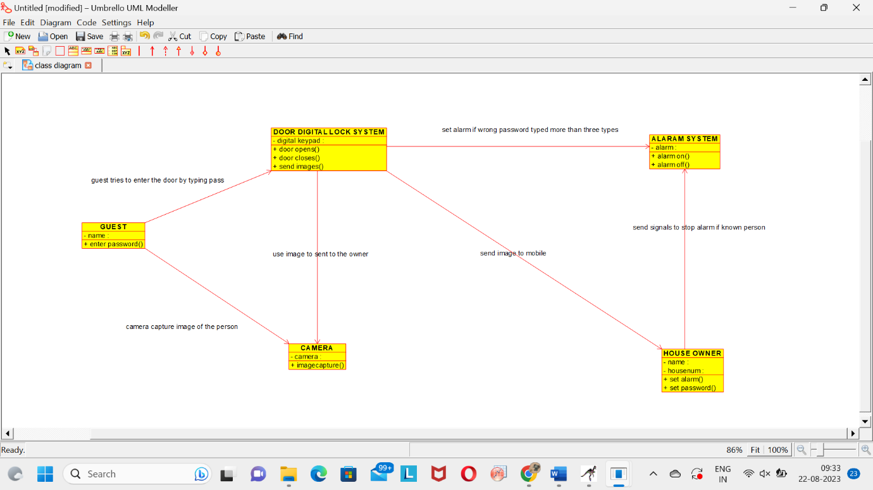

FLOWCHART OF FIBONACCI SERIES (RAPTOR)

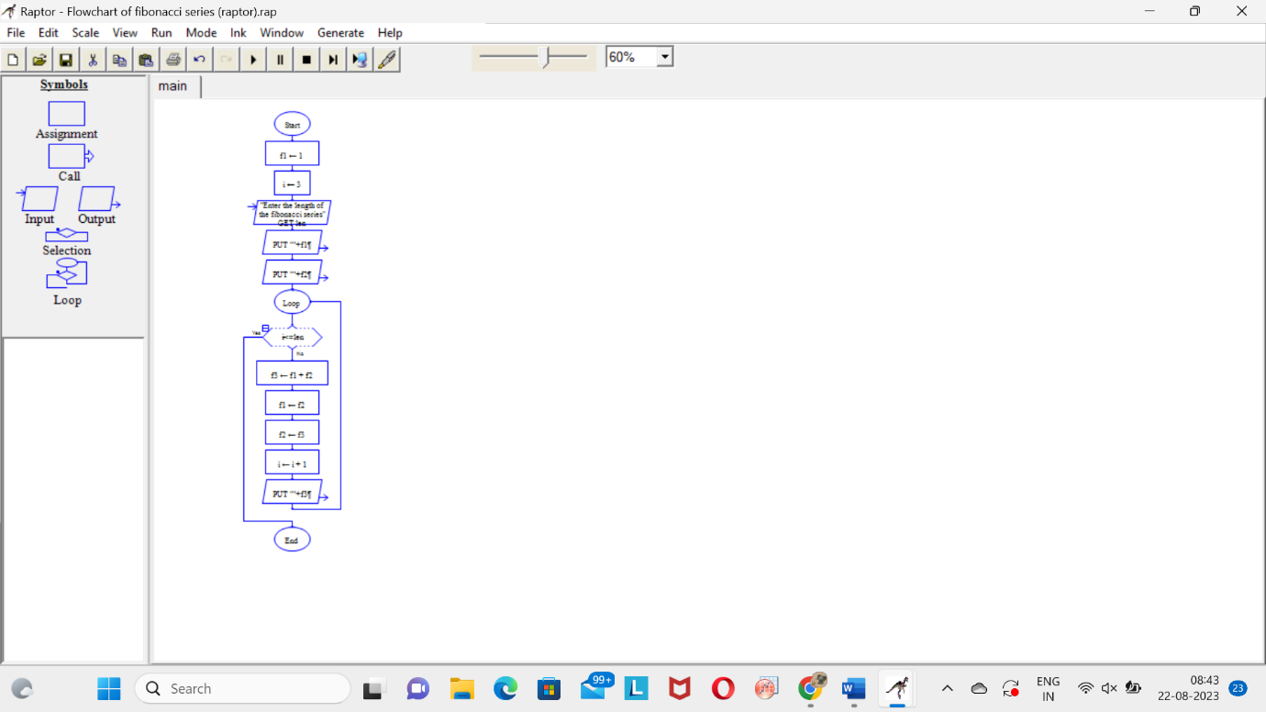

FLOWCHART OF PALINDROME (RAPTOR)

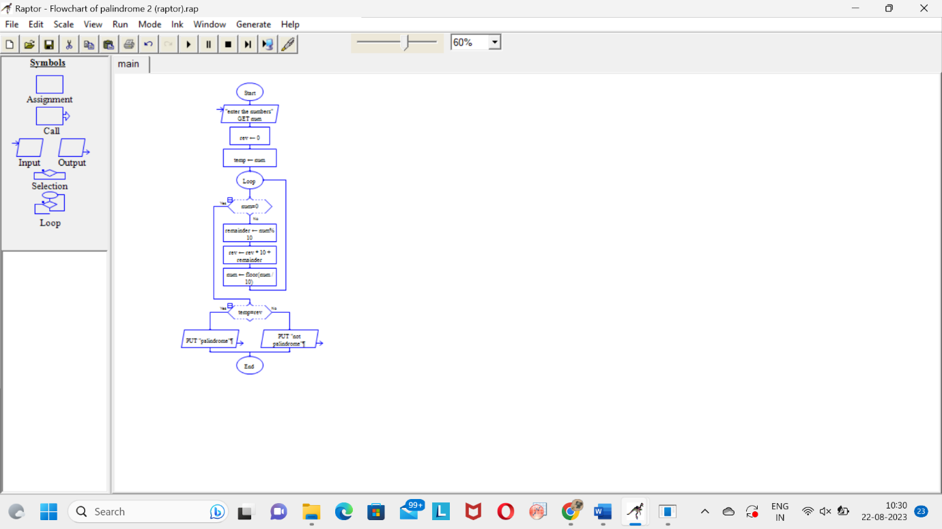

FLOWCHART OF QUOTIENT AND REMAINDER (RAPTOR)

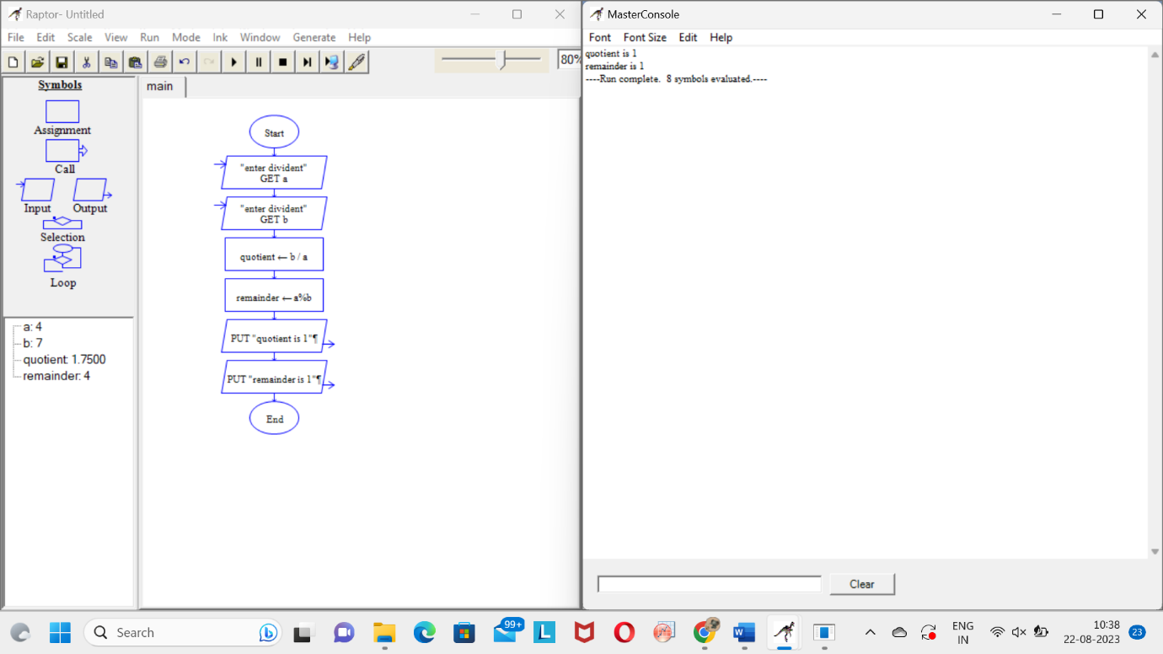

FLOWCHART OF GIVEN A NUMBER N FIND THE SMALLEST NUMBER EVENLY DIVISIBLE BY EACH NUMBER 1 TO N (RAPTOR)

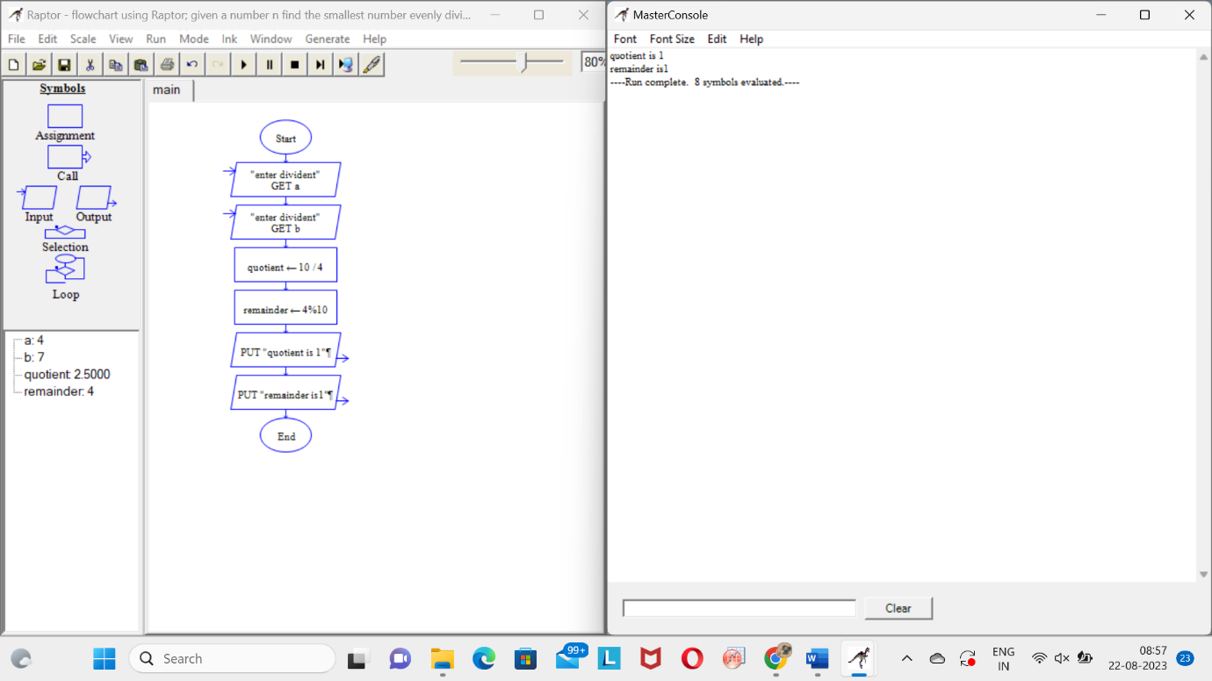

ONLINE PREPAID ACCOUNT (USE CASE)

